SCRAP VEHICLES TO ELECTRIC VEHICLE CONVERSION WEBSITE ABSTRACT:

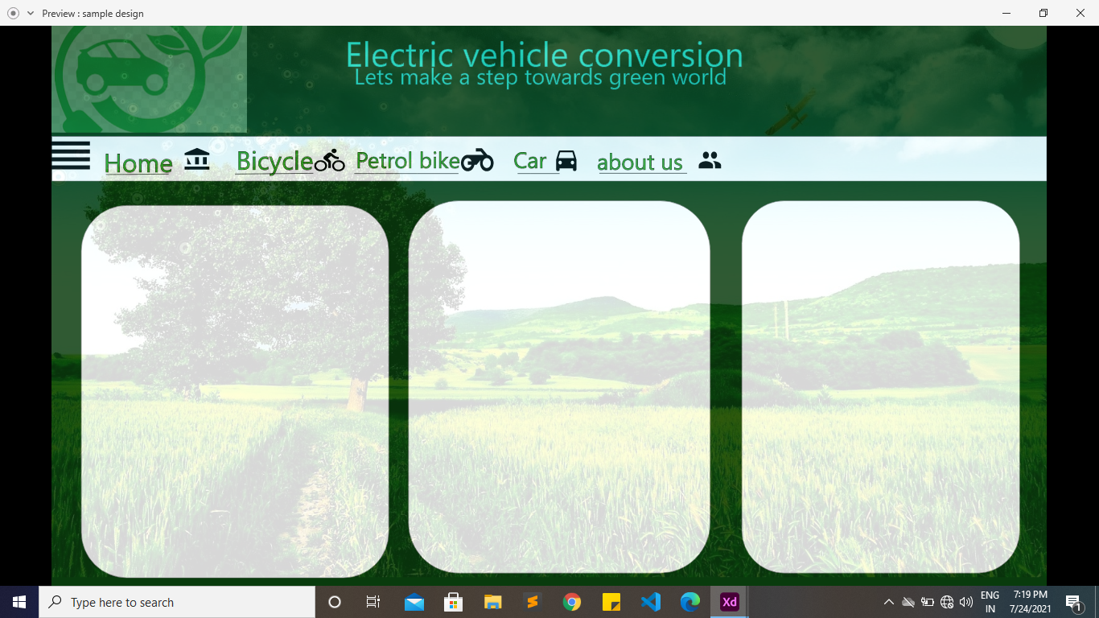

Description:

* The above layout is just an outline of the project,for reference only.This website’s main goal is to covert scrap vehicles or old cars to electric vehicles.
* In this website the user can learn the conversion of his scrap or old vehicle to a electric vehicle step by step.
* In addition to this the user can view the video of conversion attached in the website for better understanding.
* It also provides the user to convert all vehicles including car,bike,bicycle.
* In this website the links to buy essential tools and equipments link is also provided so the user need not worry where to search the equipments.
* This website has a trained professionals of EV vehicles so if user wishes to convert their vehicle they can even contact us where our team do all the work at reasonable price.
* There will be an contact form at the end of website where user can leave their contact info to book the slot to convert their vehicle.
* The company’s address also be provided so the user can come directly also.
* Over all this websites main goal is to save the environment and reduce the pollution by converting scrap old vehicles and reducing use of petrol vehicles that’s why we are providing both information and service in our website.

Thank you